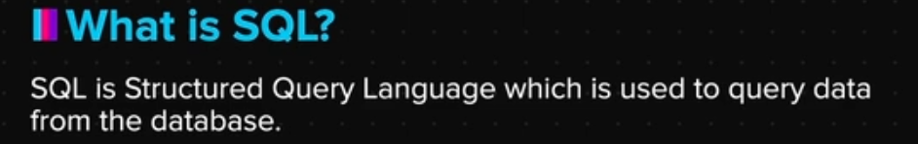

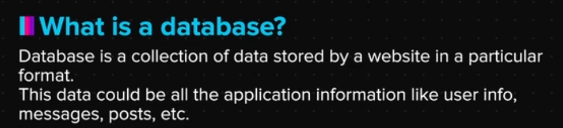

Q/A

Q. **What are injections?**

Ans. These are the vulnerabilities through which attackers gains illegal access to the data. It allows attackers to directly insert their commands/codes into the web server.

Q. **What is SQL?**

SQL is abbreviated as Structured Query language which is used to query data from the database. It helps in communicating to database software to retrieve/store data from/in the databases.

Q. **What is a database?**

Databases is a part of database software in which all the application information like user information, messages, posts etc. are placed in a structured, easy to access and secured way. These databases contain tables.; tables contain columns and rows and each row has separate cells storing data against the specific column in a specific format.

Q. **How is SQL used to communicate with database software?**

SQL is a language which is used inside Server Side Programming Languages to communicate to database software in order to Save data in databases and retrieve it later.

Q. **What are the three types of commands used in MySQL?**

**Data Definition Language (DDL):-** This command is used to define the structure of the data like how and where it would be stored. It is used in creating databases and tables, defining the structure of the tables and the columns. Examples include :- Create table, Alter table, Drop table.

**Data Manipulation Language (DML):-** These commands are used to manipulate already existing data inside a table or insert new data (rows) inside a table. It helps to edit, delete, and create rows. Example Commands: Insert into <table>, update table (rows) and delete table (rows).

**Data Query Language (DQL):-** These commands are used to Query data from the database i.e. fetch required data from the database. It is used to fetch data from all the rows, fetch specific data, sort data and even calculate values inside the rows. Examples: Select <columns> from <table>, Order by <column>.

